Enter temp in T then energy in eV and get the Boltzmann Factor calculated for you.

So, what is the Boltzmann Factor and what does it mean to get it using temp in T then energy in eV?

The Boltzmann factor tells you how likely a physical system is to have a particular amount of energy at a given temperature. It connects temperature, energy, and probability.
It's especially useful in physics when you're trying to understand whether particles have enough thermal energy to occupy a particular energy state or participate in a reaction.

1. The equation
The Boltzmann factor is:
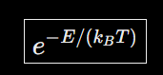
\[ \boxed{e^{-E/(k_BT)}} \]
Where:
- $E$ = energy of the state, measured relative to a reference state
- $k_{B}$ = Boltzmann constant
- $T$ = absolute temperature in kelvins (K)
- $e$ = Euler's number, approximately 2.71828
The result is a dimensionless number between 0 and 1 for nonnegative $E$.
The basic idea: the higher the energy required relative to the available thermal energy, the smaller the Boltzmann factor.

2. What does it mean to use temperature in K and energy in eV?
This is about choosing compatible units so the equation works correctly.
The Boltzmann constant can be expressed in two common ways:
Boltzmann constant | Units
$1.380649×10^{-23}$ | joules per kelvin (J/K)
$8.617333×10^{-5}$ | electronvolts per kelvin (eV/K)
An electronvolt (eV) is a unit of energy commonly used for atoms, electrons, and other microscopic physical processes.
If you measure temperature in kelvins and energy in electronvolts, use:
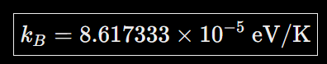
\[ \boxed{k_B = 8.617333 \times 10^{-5}\ \text{eV/K}} \]
Then the equation becomes:
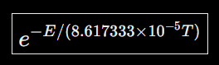
\[ \boxed{e^{-E/(8.617333\times10^{-5}T)}} \]
Here, $E$ must be in eV and $T$ must be in K.
Why? Because the units cancel:

$\frac{eV}{(eV/K)(K)}=1$
The exponent must be dimensionless. Using the wrong units would give you an incorrect result.

3. Let's work through an example
Suppose a physical process requires an energy of $0.5 eV$, and the temperature is $300 K$, approximately room temperature.

Step 1: Calculate thermal energy

$k_{B}T=(8.617333×10^{-5})(300)$

$k_{B}T≈0.02585 eV$

Step 2: Divide the energy by thermal energy

$\frac{E}{k_{B}T}=\frac{0.5}{0.02585}$

$\frac{E}{k_{B}T}≈19.34$

Step 3: Calculate the Boltzmann factor

$e^{-19.34}≈4.0×10^{-9}$
Boltzmann factor: 0.000000004
This is a very small factor, indicating that a state requiring 0.5 eV above the reference energy is strongly suppressed at 300 K.
One important distinction: the Boltzmann factor itself is not necessarily the probability. To get the actual probability of occupying an energy state, you generally normalize the factors across all available states. The number of states at each energy can also matter.

4. What happens when temperature changes?
Keep the energy fixed at $0.5 eV$, but change the temperature.
Temperature | Thermal energy $k_{B}T$ | Boltzmann factor
300 K | 0.0259 eV | $4.0×10^{-9}$
600 K | 0.0517 eV | $6.2×10^{-5}$
1,000 K | 0.0862 eV | $3.0×10^{-3}$
2,000 K | 0.1723 eV | $5.5×10^{-2}$
Boltzmann factor vs. temperature
For a fixed energy of 0.5 eV, the factor increases as temperature rises.
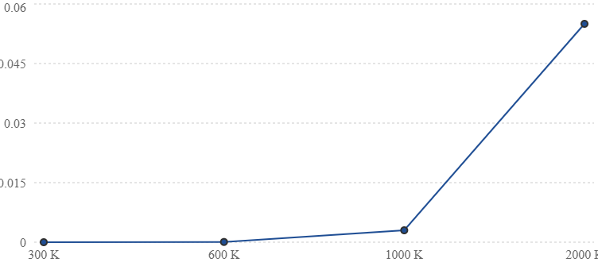
As temperature rises, higher-energy states become more accessible. Notice that doubling the temperature does not simply double the Boltzmann factor; the relationship is exponential.

5. The intuition: temperature is an energy scale
Think of $k_{B}T$ as a measure of the thermal energy scale available in a system.
- If $E≪k_{B}T$, the Boltzmann factor is close to 1.
- If $E≈k_{B}T$, the factor is approximately $e^{-1}$, or 0.368.
- If $E≫k_{B}T$, the factor becomes very small.
At room temperature, $k_{B}T$ is approximately 0.026 eV. So a process involving an energy difference of 0.5 eV requires an energy about 19 times the thermal energy scale, which explains its small Boltzmann factor.
One caveat: in chemical kinetics, the Boltzmann factor helps describe how strongly an activation energy suppresses a reaction, but it does not by itself give the reaction rate. The rate also depends on factors such as the frequency of molecular attempts and the reaction mechanism.
The key takeaway: Using temperature in kelvins and energy in eV simply means using the Boltzmann constant in eV/K. It lets you calculate the same physical quantity without converting your energy values into joules first.

